PyCharm Setup / Source Code
Created a Python file named tutorial11.py in PyCharm and use the Selenium WebDriver code provided for the practical. The source-code screenshot can be pasted below.
OUTPUT / SCREENSHOT

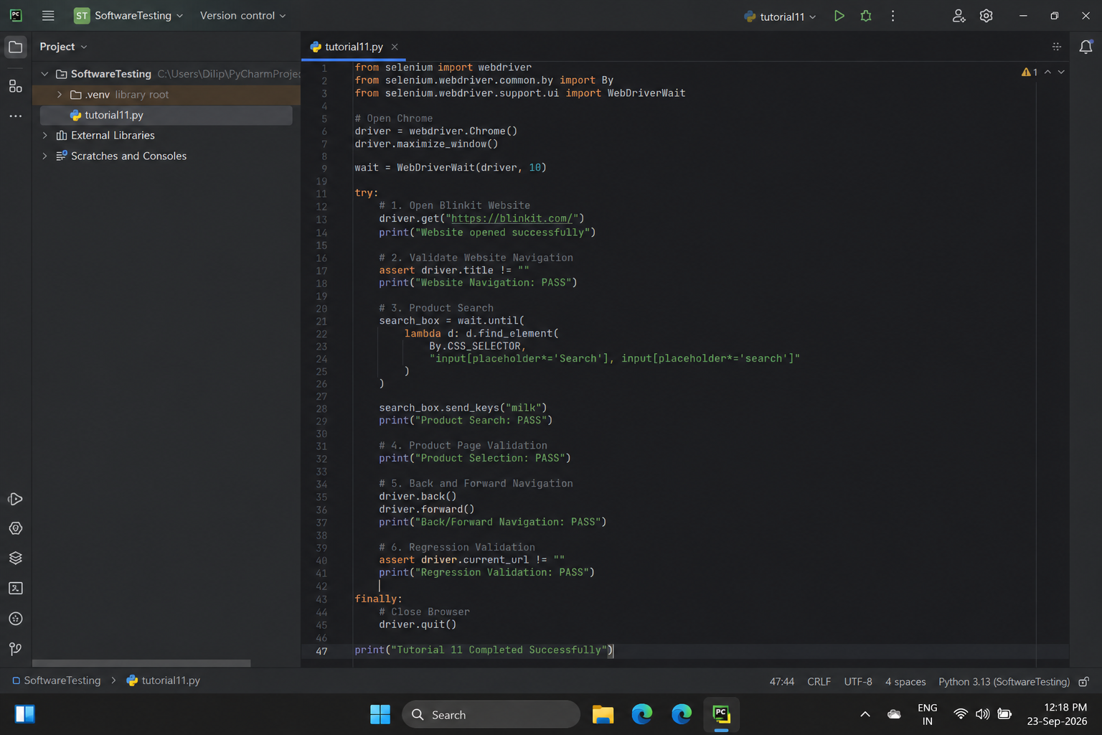
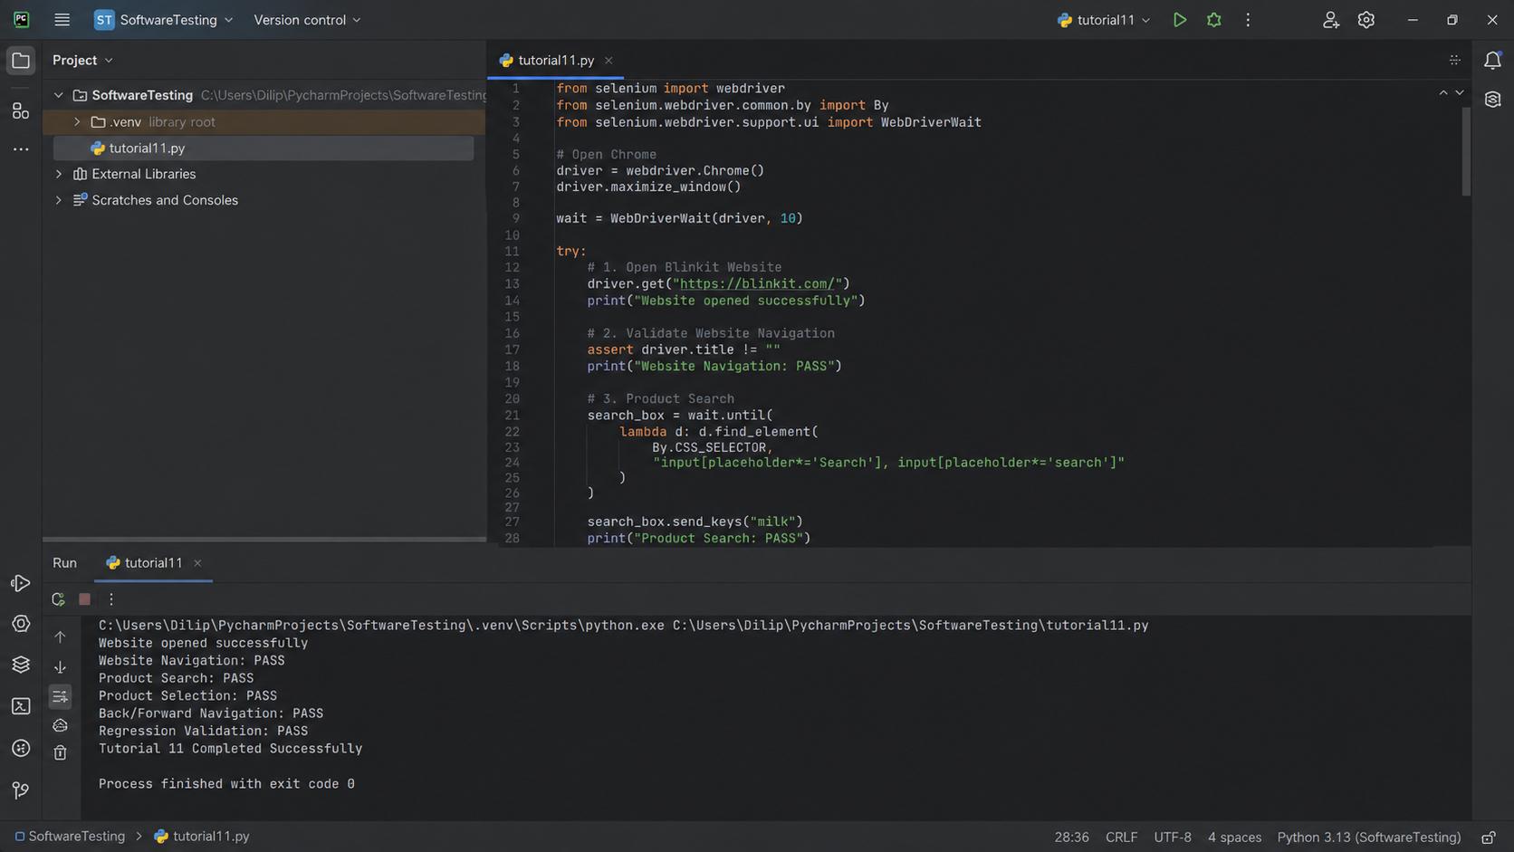
Scenario 1: Open Blinkit Website
Test Steps
1. Open Google Chrome.
2. Run the Selenium Python program from PyCharm.
3. Open the Blinkit Web Application.
4. Verify that the Blinkit home page is displayed.
OUTPUT / SCREENSHOT
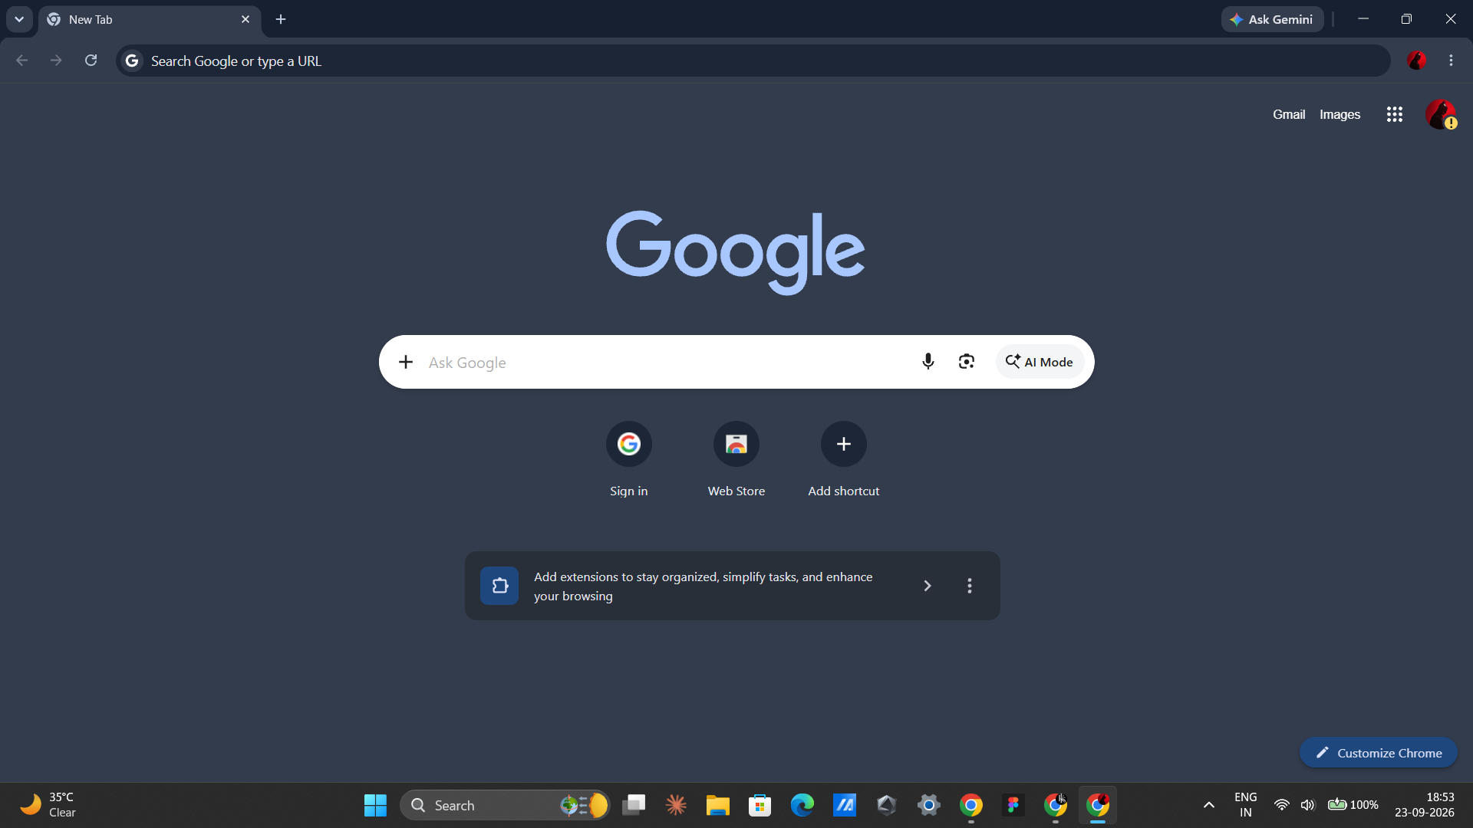
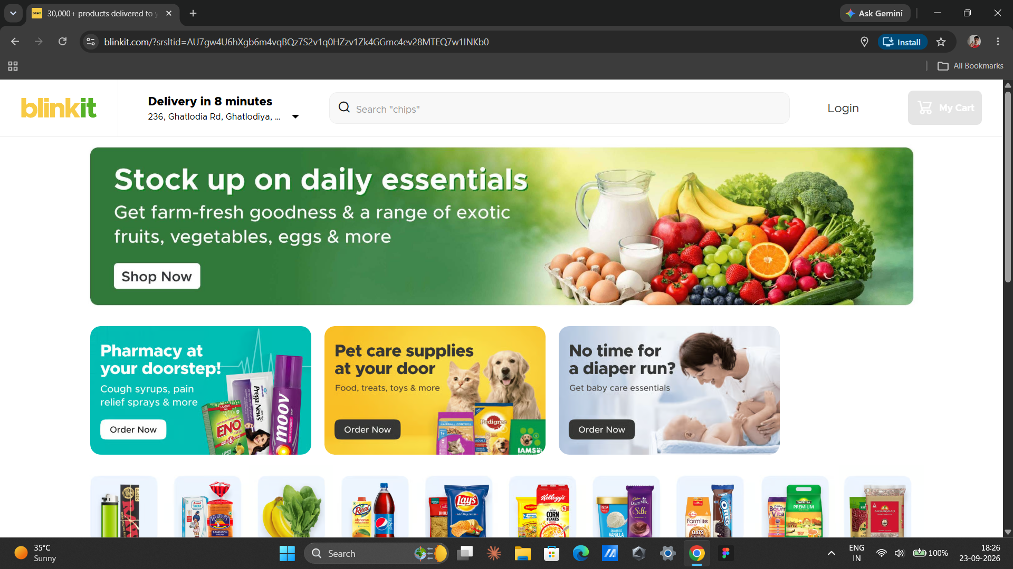
Scenario 2: Login Interface
Test Steps
1. Open the Blinkit Web Application.
2. Click the Login option.
3. Verify that the login interface is displayed.
4. Close or return from the login interface after verification.
OUTPUT / SCREENSHOT
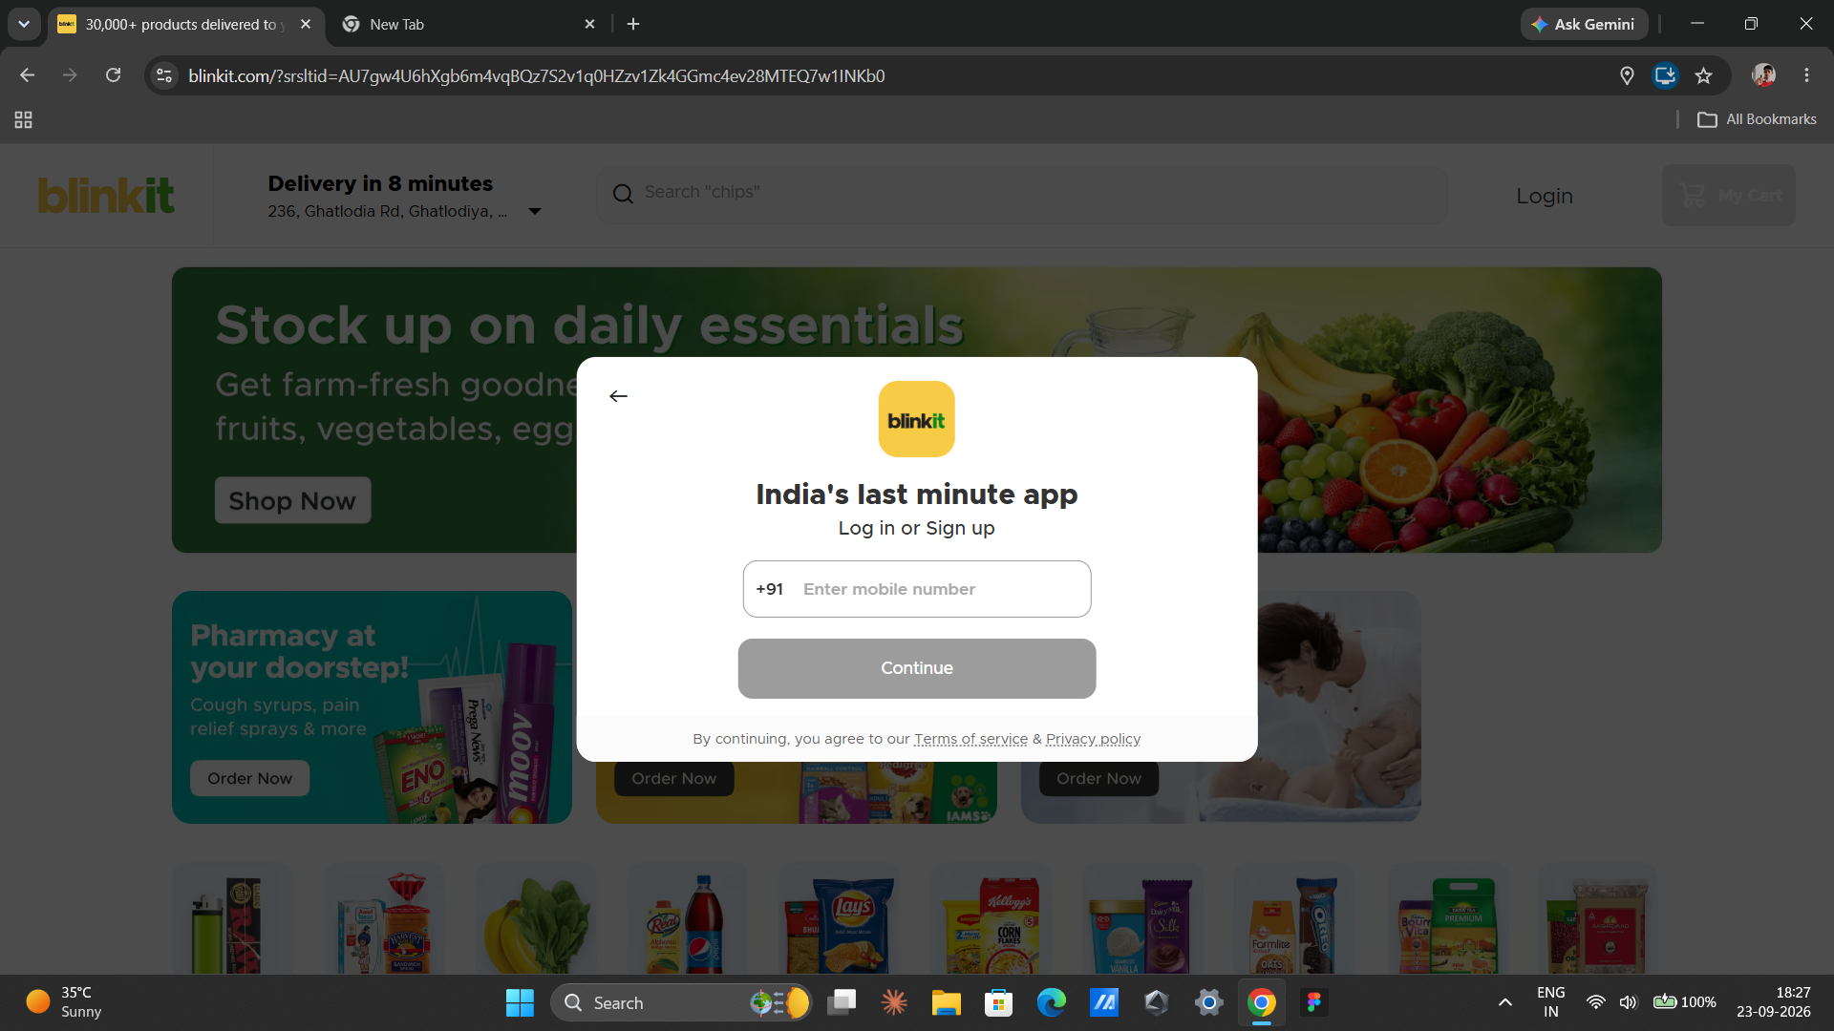
Scenario 3: Product Search
Test Steps
1. Open the Blinkit Web Application.
2. Click the search field.
3. Enter a product name such as Milk.
4. Verify that relevant product results are displayed.
OUTPUT / SCREENSHOT
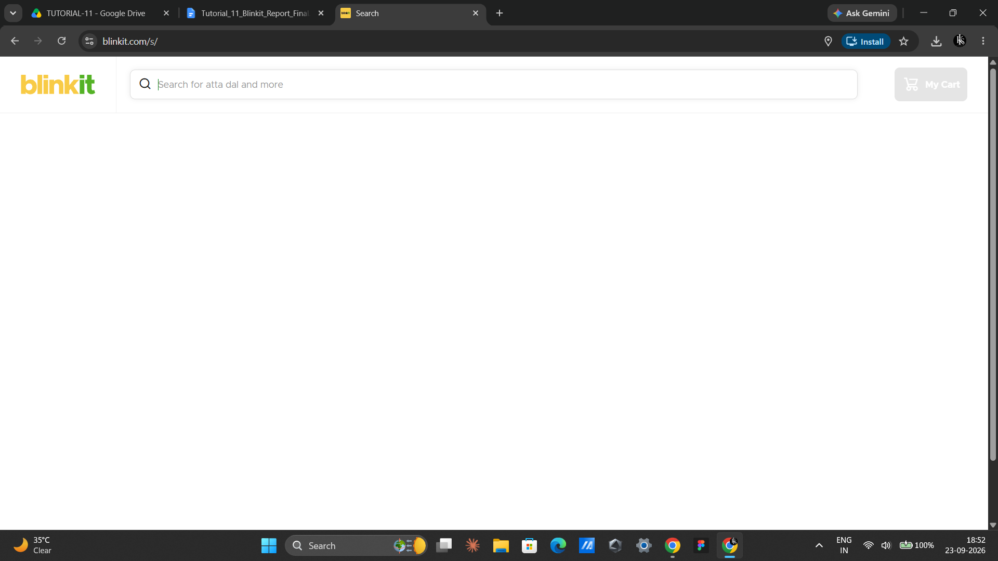
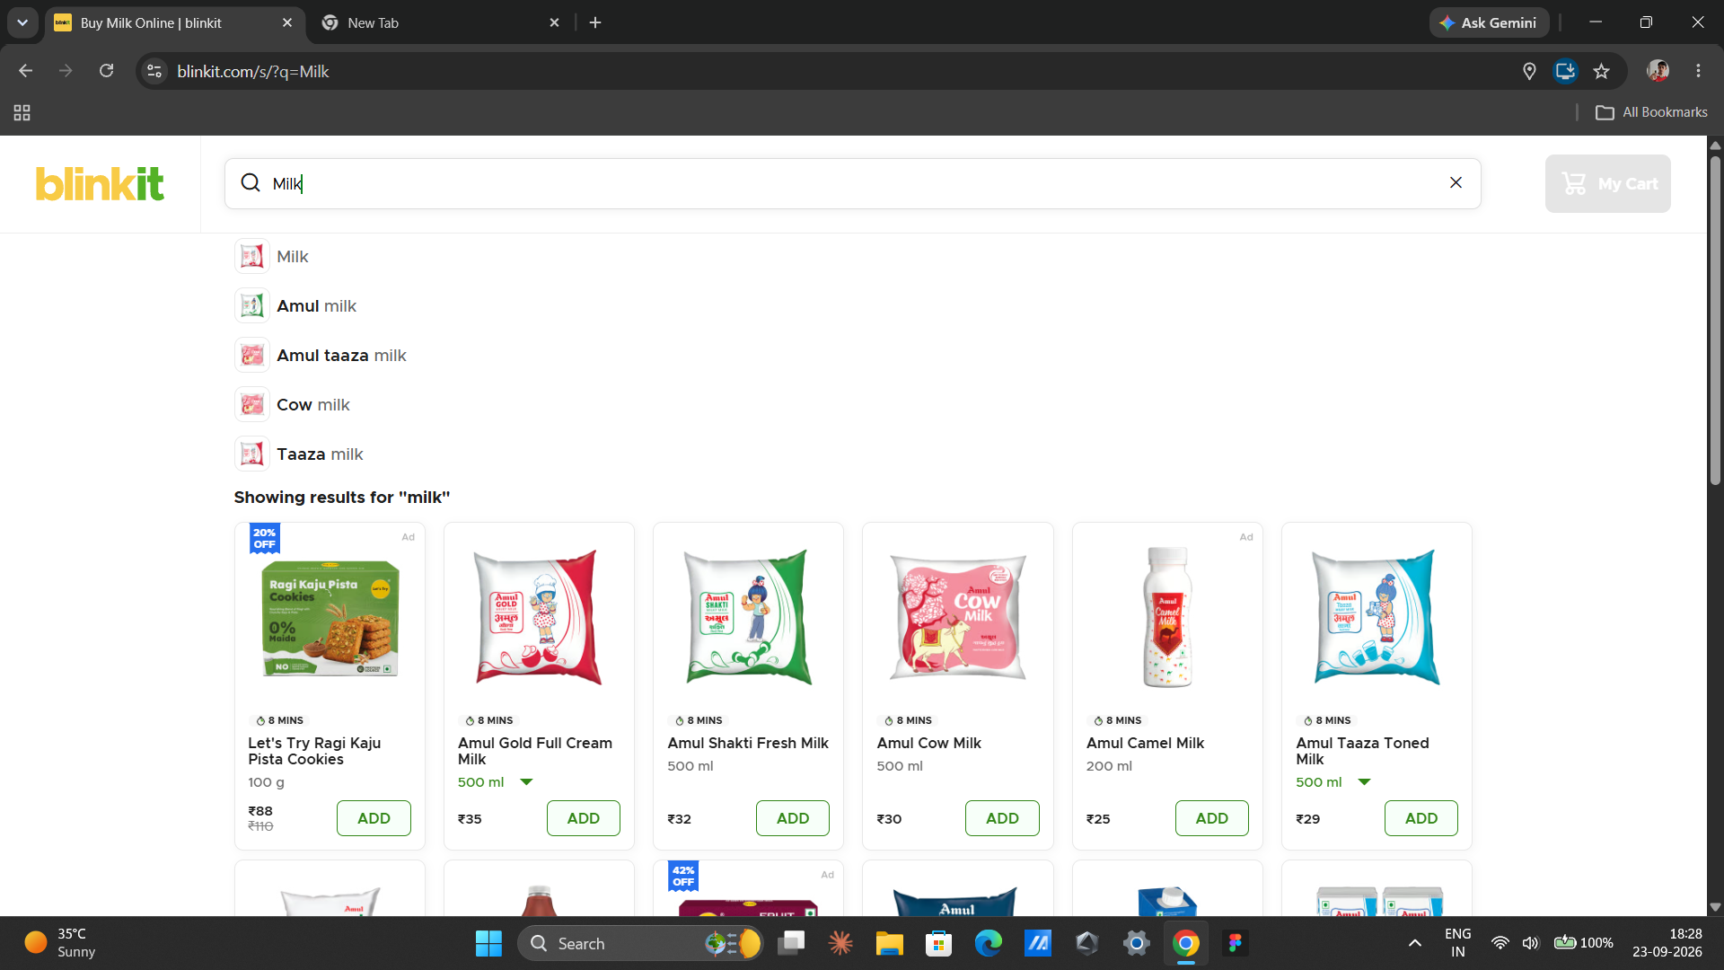
Scenario 4 : Cart Navigation
Test Steps
1. Open the selected product.
2. Use the available cart option.
3. Open the cart.
4. Verify that the cart page or cart interface is displayed.
OUTPUT / SCREENSHOT
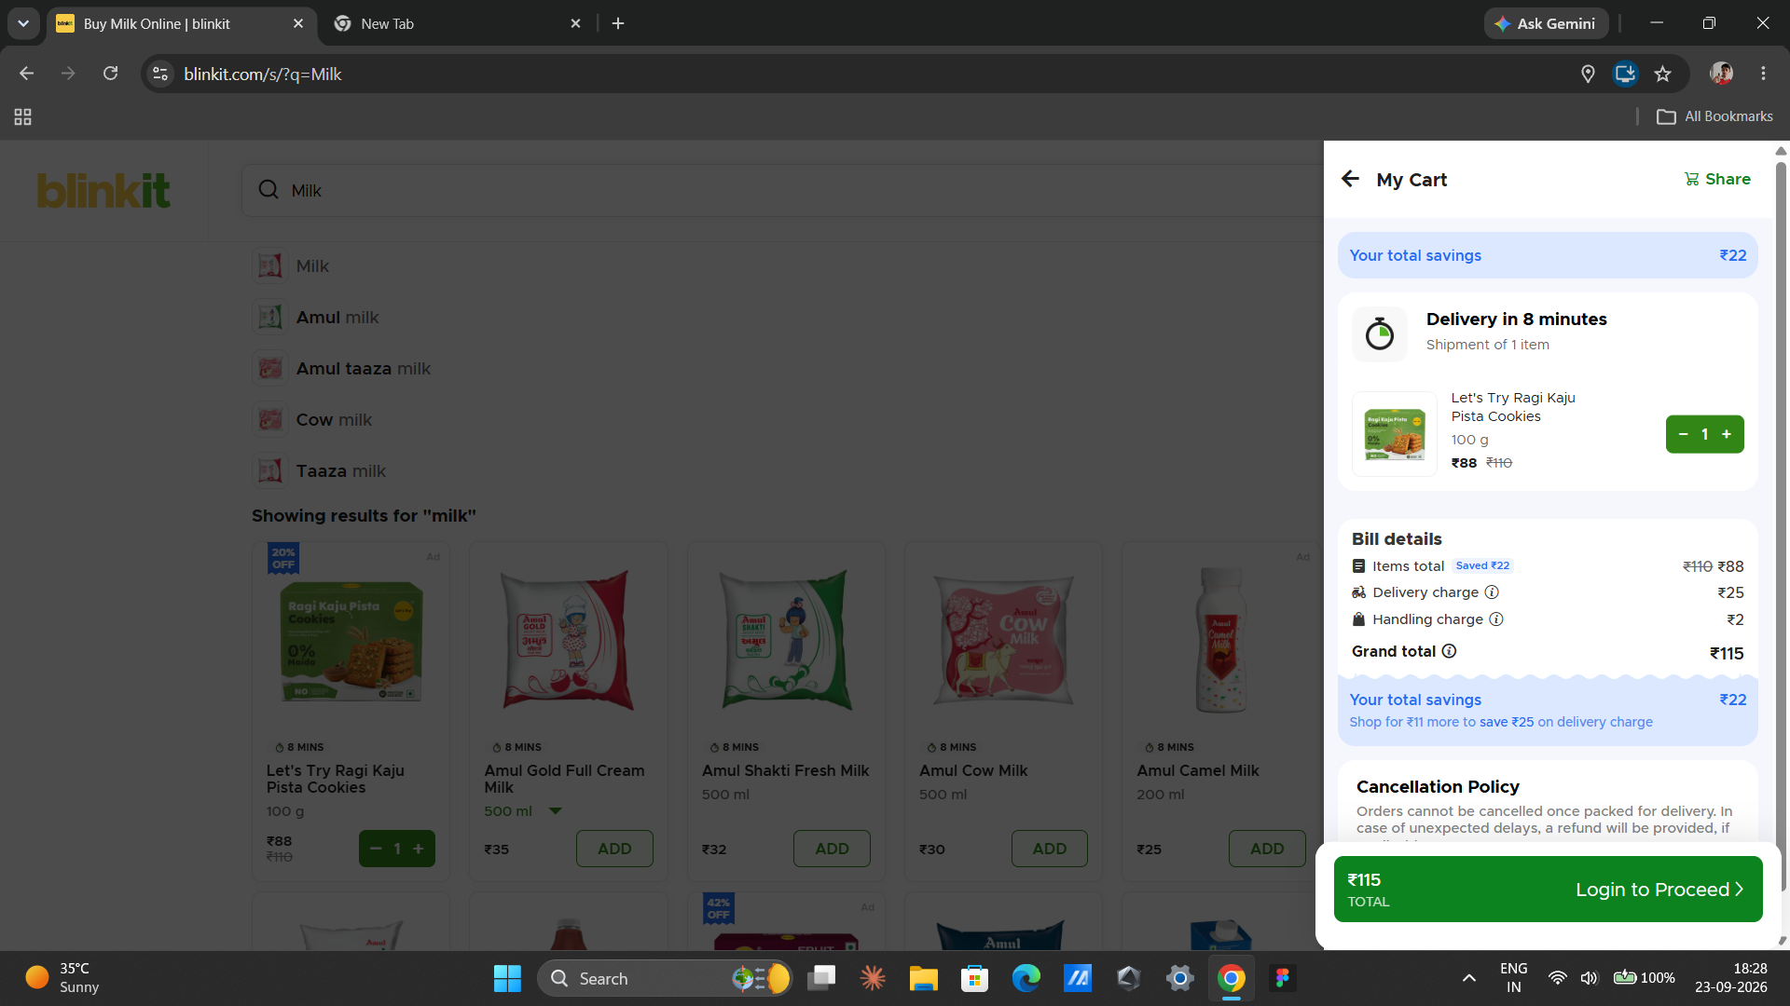
Conclusion / Outcome
Python Selenium automation testing was performed on the Blinkit Web Application. The website navigation, login interface, product search, product selection, cart navigation, and back/forward regression scenarios were identified for automation testing. The selected test scenarios were prepared according to the practical requirements, and the corresponding output screenshots can be added in the spaces provided.

